COMP-4476-FAO/FDE - Cryptography Network Security Computer Science

Assignment 3

Dmitriy Chuyko, ID: 0888211

Code has been written in JAVA using IntelliJ IDEA

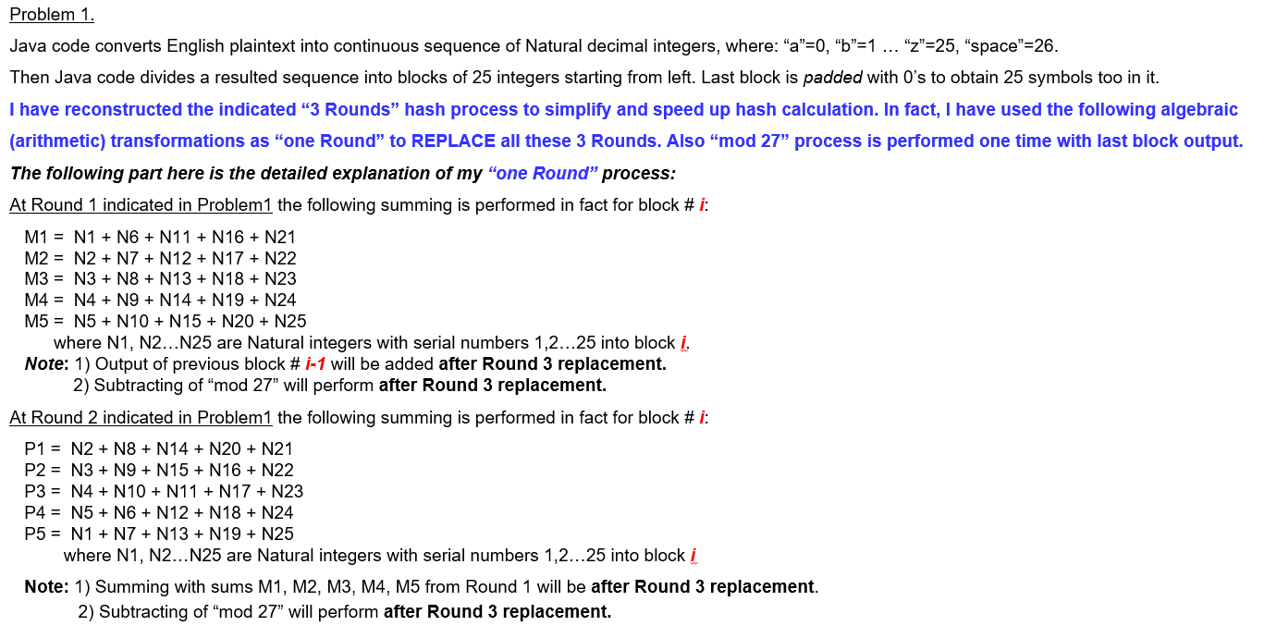

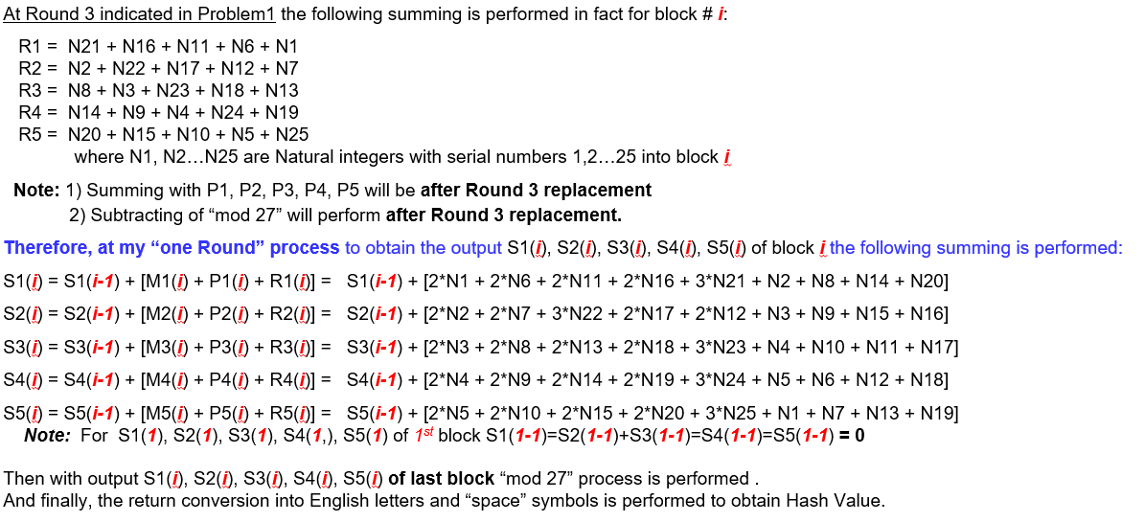

INPUT: abcdefghi jklmnopqrstuvwx

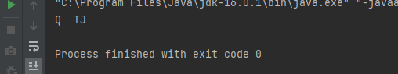

**Hash value for the plaintext: “the birthday attack can be performed for any hash functions including sha three” is UDOIY**



Correct Phrase for the DIVNJ output

**kplatzblxmoeziythe birthday attack can be performed for any hash functions including sha three**

